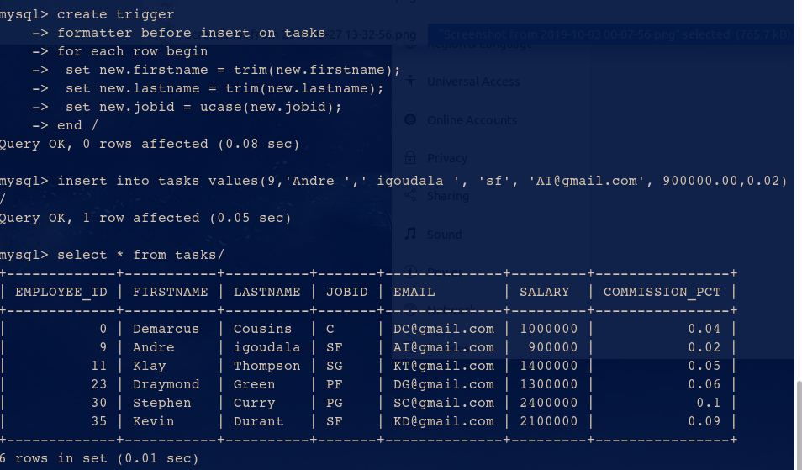
ADP ASSIGNMENT-5
--> Q1

--> Q2

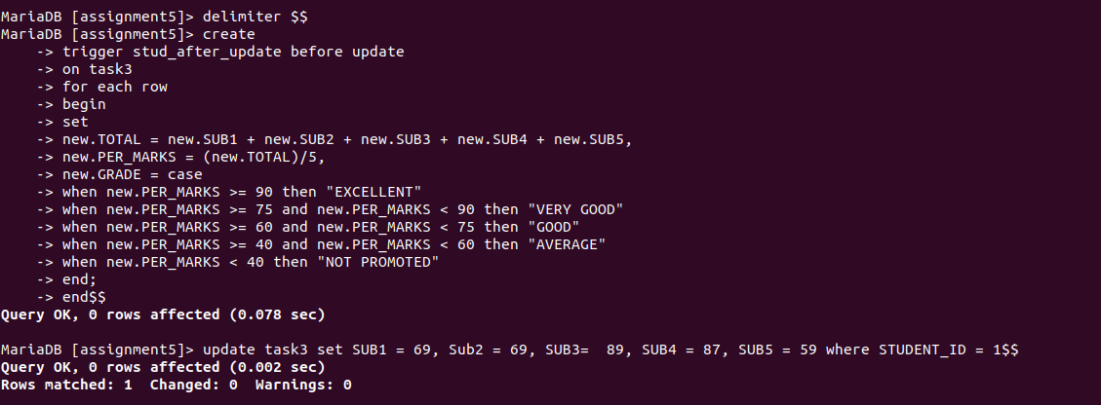
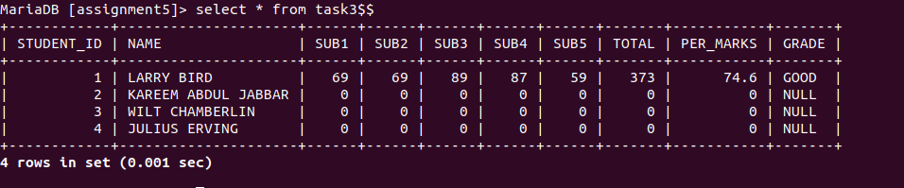

Group Members:-
1.Dipanshu Verma
2.Bhumanyu Goyal
3.Jai Luthra
4.Ayushman Dixit
5.Aman Maheshwari

